3,440% Organic Traffic Growth for a Philadelphia Personal Injury Firm

SEO

Results that speak for themselves

Key Stats & Results


2x Organic search traffic — more than doubled

65+ Web pages ranking on page 1 of Google

Behind the transformation

How a Philadelphia PI Firm Achieved 3,400% Traffic Growth
A Philadelphia personal injury law firm partnered with Rankings.io after a devastating Google penalty wiped out its organic visibility and eliminated its lead pipeline overnight. Rankings.io rebuilt the firm’s digital presence from the ground up—launching a new domain, implementing a clean SEO foundation, and executing a quality-first authority strategy. Within two years, the firm achieved 3,440% organic traffic growth, generated $1.1M in traffic value, and increased its pipeline of new cases by 50–60%, transforming organic search into one of its most reliable client acquisition channels.

FROM CHALLANGES TO SUCCESS


The Challenge
When this Philadelphia personal injury firm partnered with Rankings.io, the situation was more urgent than a typical SEO engagement: The firm was recovering from a crisis that had wiped out months of organic progress in a single algorithmic update.
The firm's founder had initially taken a hands-on approach to building online visibility, with encouraging early results. Rankings improved, new cases started coming in, and organic search began to deliver on its promise as a cost-effective lead channel.
Then disaster struck. Google flagged the links pointing to the site as spammy, damaging the domain's authority and earning it a place on Google's blacklist. Rankings collapsed from page 1 to page 7 overnight. Every lead that had been coming in through organic search disappeared almost immediately.
The firm was left competing against established Philadelphia personal injury practices running million-dollar marketing campaigns and doing so from a digital standing start, with no rankings, no authority, and no organic pipeline.
The firm's founder understood the stakes clearly: Lead generation is the lifeblood of a private practice. The best legal work in the world means nothing if qualified clients can't find the firm at the moment they need help. It was time to hand the problem to a specialist.
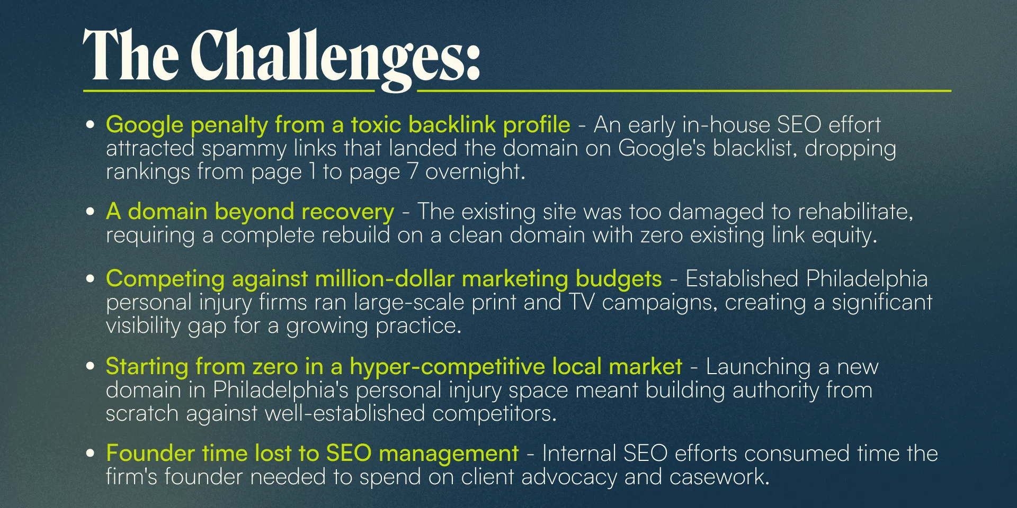



How We Did It: The Strategy
After a thorough analysis, the Rankings.io team determined that the existing domain was too compromised to rehabilitate. The only viable path was a full rebuild — a brand-new site on a clean domain, developed from zero authority in one of the most competitive local legal markets in the country.

SEO Strategy for a Philadelphia Personal Injury Firm
The strategy had to move quickly without cutting corners or repeating the ethical mistakes that caused the original penalty. We made every decision with one goal in mind: to build sustainable, Google-approved authority that compounds with time.

1. Keyword Research & New Site Architecture
Rankings.io began by mapping out the keyword landscape, identifying the search terms and topic areas most likely to attract qualified personal injury leads in Philadelphia. We built a new sitemap and keyword targeting framework around those findings before we wrote a single page of content.

2. Optimized, User-Focused Content Creation
With the site architecture established, Rankings.io developed a fully optimized, user-focused copy for every core page. The goal was content that would both rank well and convert, answering every question a prospective client might have, and guiding them toward taking action.

3. Local SEO & Citation Building
To build visibility in Google's local map pack, Rankings.io identified and secured relevant directory listings for the firm's name, new website, and address. We located existing listings from the old domain and updated or corrected them to establish a clean, consistent local presence from day one.

4. Quality-First Link Building & Scholarship Campaign
Given that a toxic link profile had caused the original penalty, link quality was non-negotiable. Rankings.io executed a large-scale, quality-first link-building campaign built on professional one-to-one outreach to industry contacts and authoritative regional sources, only targeting sites that Google already trusted.
We also launched a scholarship campaign, generating .edu backlinks from post-secondary institutions and driving a measurable increase in referral traffic. The resulting backlink profile became one of the strongest and cleanest in the Philadelphia personal injury niche, and the authority it generated lifted rankings across the entire site, including for competitive terms like “Philadelphia car accident lawyer.”



Before & After
In just two years, the firm's organic search traffic increased by 3,440%, built entirely on a brand-new domain with zero starting authority.
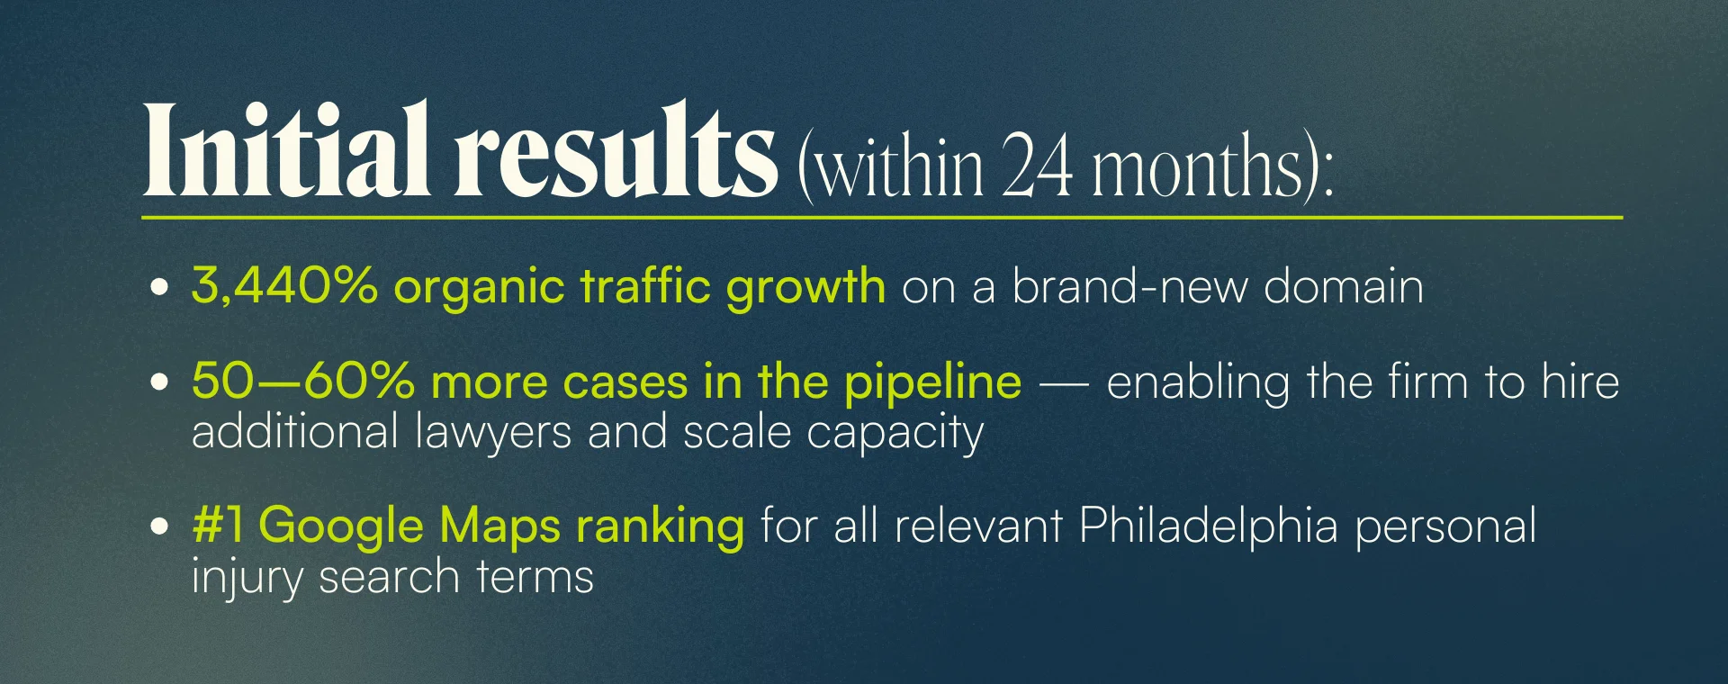
The compounding nature of the results forms the defining story of this engagement. Traffic value reached $1.1 million, representing what it would cost to replicate the same traffic through paid advertising. Year-over-year gains across impressions, clicks, and users continue to grow.

Key Wins
- 3,440% organic traffic growth in the first two years — from a brand-new, zero-authority domain
- 50–60% more cases in the pipeline within 24 months of the engagement
- #1 Google Maps ranking for all relevant personal injury search terms in Philadelphia
- One of the strongest backlink profiles in the niche — built entirely through ethical, quality-first outreach and scholarship campaigns
- $1,100,000 in cumulative traffic value
- +133% year-over-year (YoY) impressions, +44% YoY clicks, +21% YoY new users — compounding year over year
- Firm founder freed from SEO management — able to return focus to client advocacy and casework

Ready to Grow Your Firm?
This case study shows what Rankings.io can do even in the most difficult starting conditions: a penalized domain, a brand-new site, and a market full of well-funded competitors. The results compounded year after year.
At Rankings.io, we specialize exclusively in SEO for lawyers. Whether you're rebuilding from a penalty or starting a new practice, we bring the expertise, ethics, and long-term commitment needed to turn organic search into your most valuable case source.
You can be the best lawyer in the world, but if no one can find you, leads go elsewhere. Let's fix that.

